Mohamed Shafi Uzman Fassy – (102608927)
COS30031 – Task 2 – 9th August 2023

Release Notes:
- C++ Recourse Links that I found and used were:
  - C++ Reference / Cheat Sheet - https://www.codewithharry.com/blogpost/cpp-cheatsheet/
  - Visual Studio Code Keyboard Short-Cut Reference Sheet –
https://code.visualstudio.com/shortcuts/keyboard-shortcuts-windows.pdf
  - Online Code Debugging Tool –
https://www.onlinegdb.com/
- Lab Demo Code Snippets
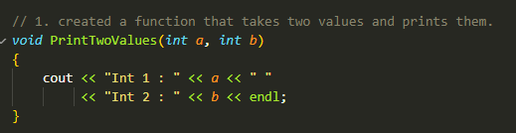
Figure 1 Function that prints 2 values.
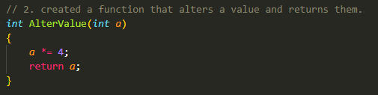
Figure 2 Function that alters a value.
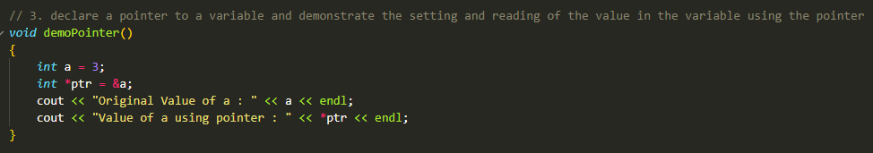
Figure 3 Function that demonstrates pointers and reading values in a pointer.
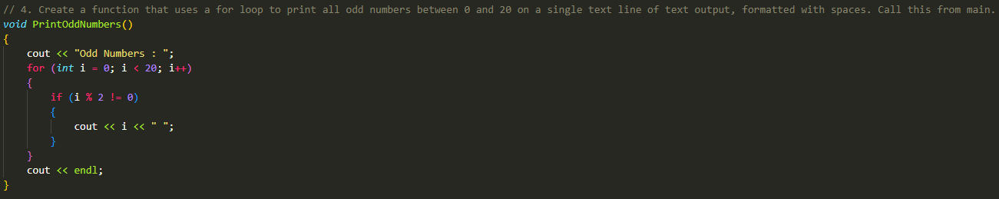
Figure 4 Function that prints odd numbers.
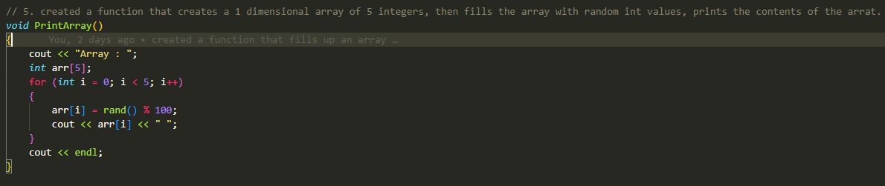
Figure 5 Function that prints a 1-dimensional array that contains 5 integers.
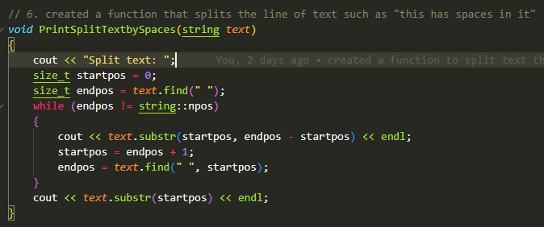
Figure 6 Function that splits text that have spaces between them into separate text lines.
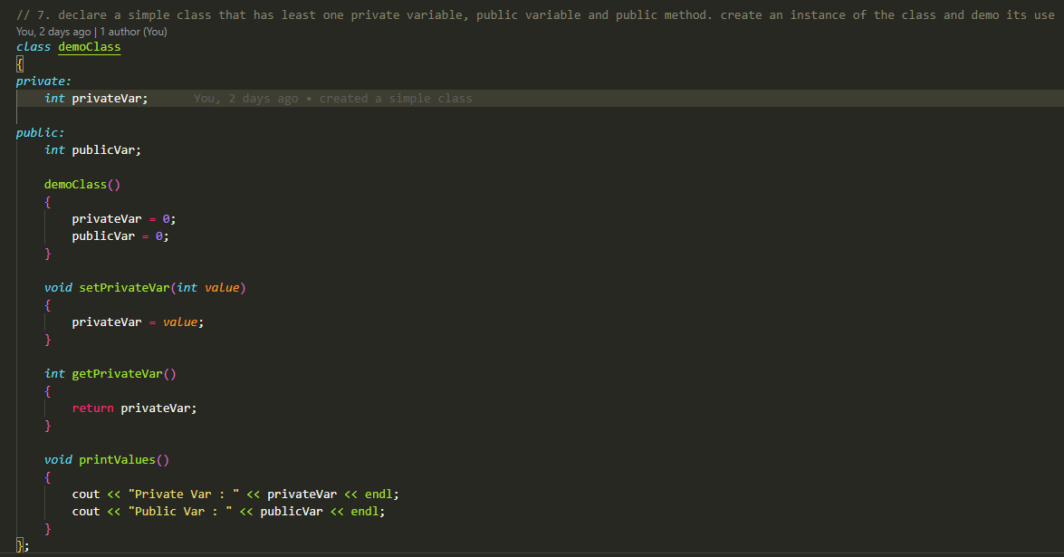
Figure 7 Function that demonstrates how classes work.

